**Candidate’s Name: …………………………………………………………………………...**

**Signature: …………………………………**

**545/1**

**CHEMISTRY**

**Paper 1**

**2024**

1 and 1/2 hours

DAAR SSALAAM SECONDARY SCHOOL

SENIOR THREE CHEMISTRY END OF TERM TWO

**CHEMISTRY DEPARTMENT EXAMINATIONS BOARD**

**Uganda Certificate of Education**

CHEMISTRY

**Paper 1**

1 hour and 30 minutes

**INSTRUCTIONS TO CANDIDATES:**

*This paper has* **4** *examination items which are divided into* **parts; I** *and* **II.** *Answer* **one** *item from* **each** *part.*

*Answers***must** *be written in the answer booklet*(*s*) *provided.*

*Answer* **two** *items in all.*

*Any additional item answered will* **not** *be scored.*

|  |  |  |  |  |  |
| --- | --- | --- | --- | --- | --- |
|  | **For Examiner’s Use Only** | | | |  |
| **1** | **2** | **3** | **4** |  |  |
|  |  |  |  |  |  |

© *2024 ChemistryMaestro311 0756223216* **Turn Over**

## Part I

*Answer* **one** *item from this part in the answer booklet*(*s*) *provided.*

One of the large scale use of Sulphuric acid is to manufacture paints. Due to increased demand of paints countrywide, the government is seeking to ensure that there is a steady supply of Sulphuric acid to be used to manufacture the needed paints. The government has hired an investor to set up a Sulphuric acid manufacturing plant in Kimu town.

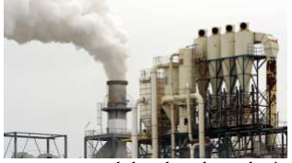

The locals of Kimu town are concerned about how the production process will be conducted, its environmental effects and how will they benefit when the plant is constructed in their town. Task: Prepare a presentation you will make answering concerns of the locals. (11 score)

**Item 4**

Ethanol is a major component in sanitizers. Following an increased demand for sanitizers countrywide due to covid-19 spike. The government has hired a local investor to set up an ethanol brewing plant in Jinja industrial area to make more ethanol to be used in sanitizers.

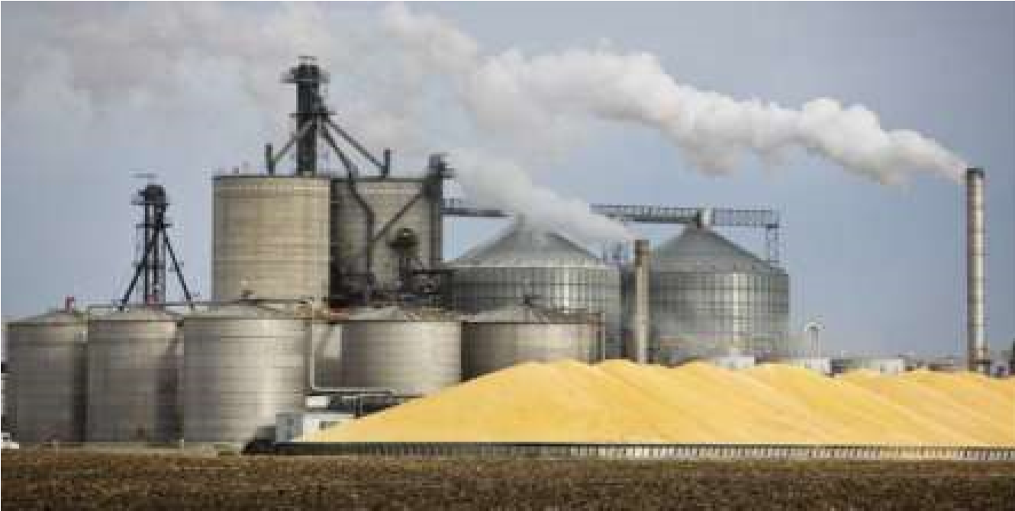

The Jinja city council would like to know how ethanol will be produced and how the plant will impact the environment of their city.

**Task:**

Make a write up you will deliver to Jinja city council answering their concerns. (*11 scores*) **Part II**

*Answer* **one** *item from this part in the answer booklet*(*s*) *provided.*

**Item 5**

There has been a nationwide destruction of natural resources due to increasing population and human activities. This has attracted the attention of officials from National Environment Management Authority (NEMA).

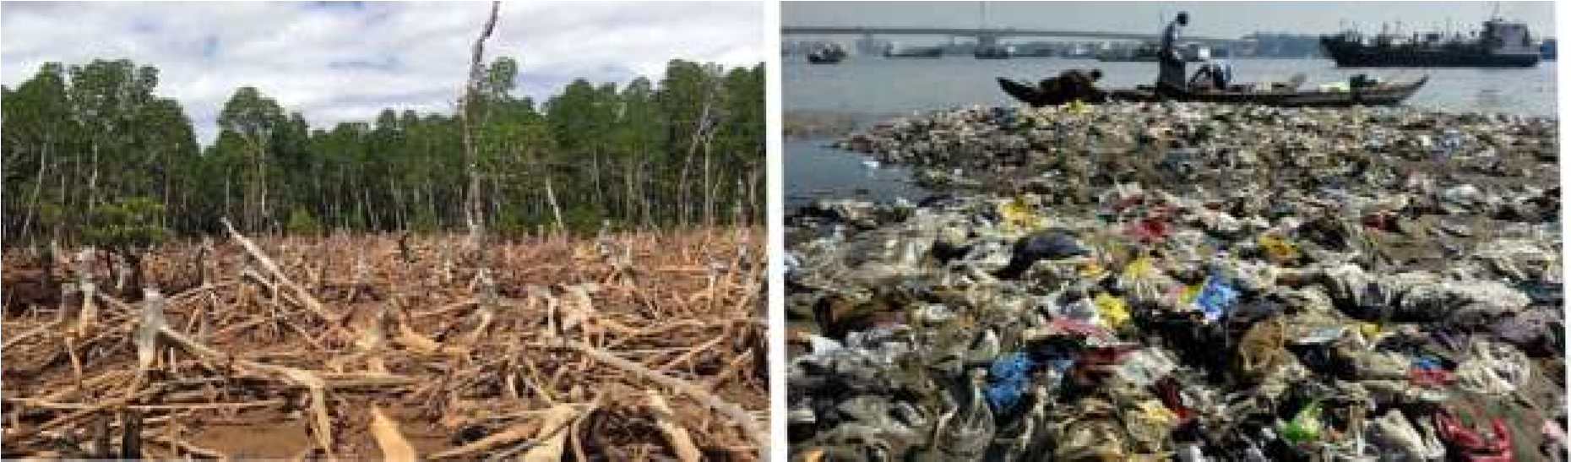

The officials are planning to sensitize people countrywide about natural resources conservation through organizing workshops in different districts.

**Task:**

As a chemistry learner, write a message you would deliver upon invitation in workshop

Organized in your district. (*11 scores*)

# Turn Over

**Item 6**

People in Seroma village have often been found to be carrying out bush burning, over grazing and stone quarrying. They are now facing breathing problems and low soil fertility and are now wondering why this is happening.

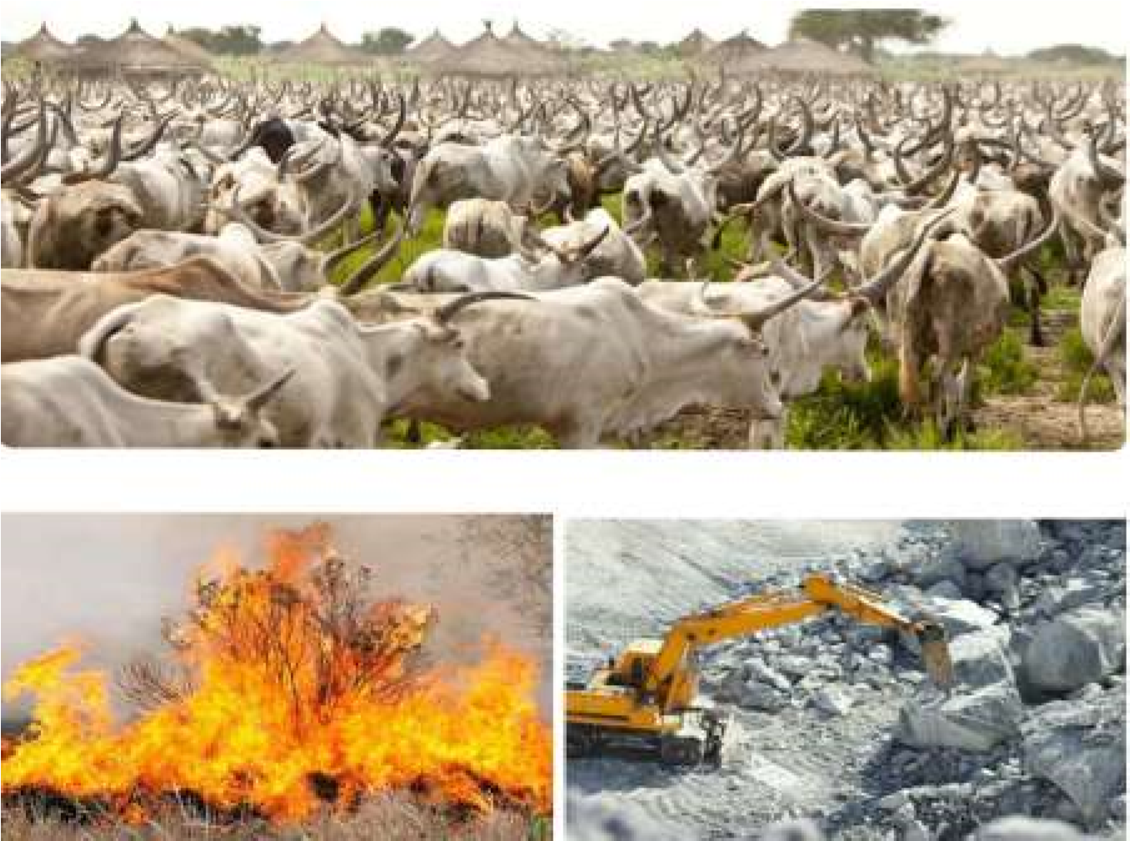

The LC1 chairman has organized an emergency village meeting with a theme,

“**ENVIRONMENT CONSERVATION, A RESPONSIBILITY FOR ALL.”**

**Task:**

As a chemistry student and one of the village members, make a write up about the theme that

You will present in the village meeting. (*11 scores*)

# END